 | 12.1.36 Editors - Geometry Nodes Editor - Header - Add Menu - Utilities - Color
Table of content
Detailed table of content 1
Add menu - Utilities - Color 3
Blackbody 3
Color Ramp 4
RGB Curves 6
Combine Color 6
Mix Color 7
Separate Color 11

Detailed table of content
Detailed table of content
Detailed table of content 1
Add menu - Utilities - Color 3
Blackbody 3
Inputs 4
Temperature 4
Outputs 4
Color 4
Color Ramp 4
Inputs 4
Factor 4
Properties 4
Color Ramp 4
Controls 4
+ 4
- 4
Tools menu 4
Flip Color Ramp 4
Distribute Stops from Left 4
Distribute Stops Evenly 4
Eyedropper (pipette icon) E 4
Reset Color Ramp 5
Color Mode 5
RGB 5
HSV/HSL 5
Interpolation 5
Ease 5
Cardinal 5
Linear 5
B-Spline 5
Constant 5
Color Ramp 5
Active Color Stop elements 5
Choose active color stop 5
Pos 5
Outputs 5
Image 5
Alpha 5
RGB Curves 6
Input 6
Factor 6
Color 6
Combine Color 6
Input 6
Mode 6
Input – RGB mode 6
R, G and B 6
Input – HSV mode 6
H , S and V 6
Input – HSL mode 6
H , S and L 6
Tools 6
Reset View 6
Vector Handle 7
Auto Handle 7
Auto Clamped Handle 7
Extend horizontal 7
Extend extrapolated 7
Reset Curve 7
Output 7
Color 7
Use Clipping 7
Delete Points 7
Mix Color 7
Data Type 7
Color 8
Inputs 8
Factor 8
Color 1 8
Color 2 8
Properties 8
Mix 8
Clamp Result 8
Clamp Factor 8
Outputs 8
Result 8
Vector 8
Inputs 8
Factor 8
A 8
B 8
Properties 9
Factor Mode 9
Clamp Factor 9
Outputs 9
Result 9
Float 9
Inputs 9
Factor 9
A 9
B 9
Properties 9
Clamp Factor 9
Outputs 9
Result 9
Properties 9
Curve Field 9
Channel buttons 9
Navigation elements 10
Zoom in and out 10
Use Clipping 10
Tools 10
Reset View 10
Extend horizontal 10
Extend extrapolated 10
Reset Curve 10
Curve edit field 10
Selecting Points 10
Adding Points 10
Curve point settings 11
Vector Handle 11
Auto Handle 11
Auto Clamped Handle 11
Output 11
Color 11
Separate Color 11
Input 11
Mode 11
Image 11
Output 11
Red, Green, Blue and Alpha 11

Add menu - Utilities - Color
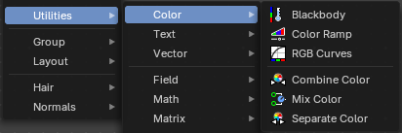
Here you find mainly nodes to convert color values.

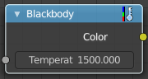
Blackbody
The Blackbody node converts a blackbody temperature to RGB value. This can be useful for materials that emit light at natural occurring frequencies.

Inputs

Temperature
The temperature in Kelvin.

Outputs

Color
RGB color output.

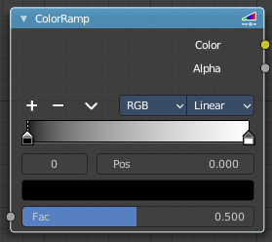
Color Ramp
The Color Ramp Node is used for mapping values to colors with the use of a gradient.

Inputs

Factor
The Factor input is used as an index for the color ramp.

Properties

Color Ramp
Color Ramps enables the user to specify a range of colors based on color stops. The color between the color stops gets interpolated.

Controls

+
Add a stop to your color ramp. The stop will be added after the selected one, in the middle to the next one.

-
Deletes the selected color stop from the list.


Tools menu

Flip Color Ramp
Flips the gradient, inverting the values of the color ramp.

Distribute Stops from Left
Rearrange the stops so that every step has the same space to the right.

Distribute Stops Evenly
Space between all neighboring stops becomes equal.

Eyedropper (pipette icon) E
An Eyedropper to sample a color or gradient from the interface to be used in the color ramp.

Reset Color Ramp

Resets the color ramp to its default state.

Color Mode

RGB
Blends color by mixing each color channel and combining.

HSV/HSL
Blends colors by first converting to HSV or HSL, mixing, then combining again. This has the advantage of maintaining saturation between different hues, where RGB would de-saturate, this allows for a richer gradient.


Interpolation

Ease
Uses an Ease Interpolation for the color stops.

Cardinal
Uses a Cardinal Interpolation for the color stops.

Linear
Uses a Linear Interpolation for the color stops.

B-Spline
Uses a B-Spline Interpolation for the color stops.

Constant
Uses a Constant Interpolation for the color stops.

Color Ramp
The color band. A click at one of the color stops makes it the active one. You can move the color stops by clicking at them and dragging them around.

Active Color Stop elements

Adjust the active color stop.

Choose active color stop
Choose the color stop by index.

Pos
The position of the active color stop. The range goes from 0.000 to 1.000

Outputs

Image
Standard image output.

Alpha
Standard Alpha Output.

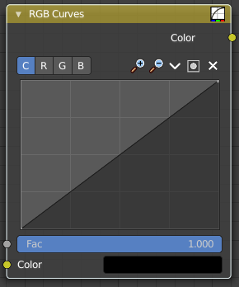
RGB Curves
Adjust the RGB channels by curves.

Input

Factor
The blend factor.

Color
The input color.

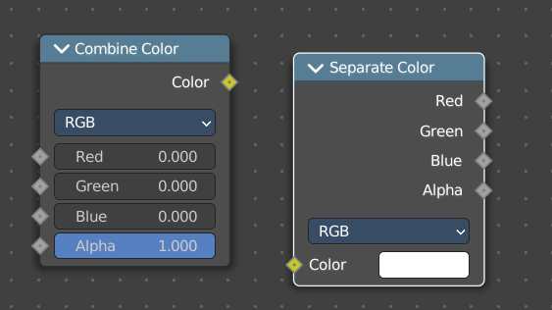
Combine Color
Combine the single RGBA channels into a single image.

Input

Mode
- RGB colour processing
- HSV colour processing
- HSL colour processing

Input – RGB mode

R, G and B
The red, green and blue channels of an image.

Input – HSV mode

H , S and V
The Hue, Saturation and Value channels of an image.

Input – HSL mode

H , S and L
The Hue, Saturation and Luminescence channels of an image.

Tools

Tools is a menu where you can find some curve related tools.

Reset View
Resets the curve windows zoom.

Vector Handle
Set handle type to Vector.

Auto Handle
Set handle type to Auto.

Auto Clamped Handle
Set handle type to Auto Clamped.

Extend horizontal
Extends the curve before the first curve point and behind the last curve point horizontally.

Extend extrapolated
Extends the curve before the first curve point and behind the last curve point extrapolated.

Reset Curve
Resets the curve to the initial shape.

Output

Color
Color output.


Use Clipping
Clipping options. Set up clipping for the stroke.

Delete Points
Deletes selected curve points.

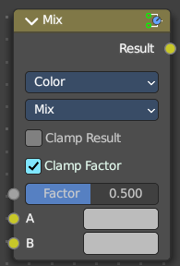
Mix Color
The mix Color node is in real the Mix node in Color mode. It is shared across editors.
The Mix node is meant to mix values. This can be colors, or also a vector or a single value.
Note that the Mix Color node does not start in Color mode when you insert it from the sidebar due a techical limitation in the Blender Python api. Here you have to manually switch to the color mode.

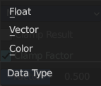
Data Type
The mode in which the node works.

Color
The Mix Node in color mode mixes images by working on the individual and corresponding pixels of the two input images. Called “MixRGB” in the shader and texture context.

Inputs

Factor
Controls the amount of influence the node exerts on the output image.

Color 1
Usually the background image. The image size and resolution sets the dimensions of the output image.

Color 2
Usually he foreground image.

Properties

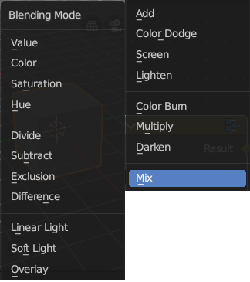
Mix
Choose the different blending modes.
Add, Subtract, Multiply, Screen, Divide, Difference, Darken, Lighten, Overlay, Color Dodge, Color Burn, Hue, Saturation, Value, Color, Soft Light, Linear Light.

Clamp Result
Clamp the result to 0, 1 range.

Clamp Factor
Clamp the factor to 0, 1 range.

Outputs

Result
Standard output.

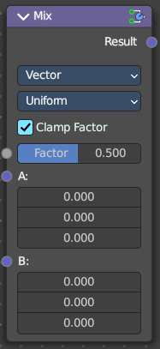
Vector
The vector mode allows you to mix vectors.

Inputs

Factor
Controls the amount of influence.

A
The input vector.

B
The output vector.

Properties

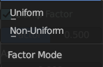
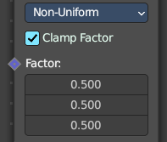
Factor Mode
Use a single factor for all values, or a factor per value.

Clamp Factor
Clamp the factor to 0, 1 range.

Outputs

Result
Standard output.

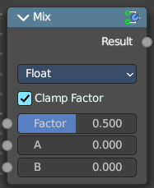
Float
The vector mode allows you to mix vectors.

Inputs

Factor
Controls the amount of influence.

A
The input value.

B
The output value.

Properties

Clamp Factor
Clamp the factor to 0, 1 range.

Outputs

Result
Standard output.

Properties

Curve Field

Channel buttons
Clicking on one of the channels displays the curve for each.
C (Combined RGB), R (Red), G (Green), B (Blue).

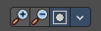
Navigation elements
They are described from left to right.

Zoom in and out
The two buttons with the magnifying glass at it zooms in and out in the curve window.

Use Clipping
Clipping options. Set up clipping for the stroke.

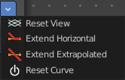
Tools
Tools is a menu where you can find some curve related tools.

Reset View
Resets the curve windows zoom.

Extend horizontal
Extends the curve before the first curve point and behind the last curve point horizontally.

Extend extrapolated
Extends the curve before the first curve point and behind the last curve point extrapolated.

Reset Curve
Resets the curve to the initial shape.

Curve edit field
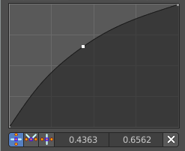
Create and tweak a Bezier curve that varies the input levels (X axis) to produce an output level (Y axis).

Selecting Points
You can select curve points. This reveals two edit boxes for the x and y coordinate of this point.
Selected points can be moved around. Left click at them, hold the mouse button down and move them to a new location.

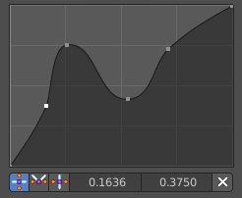
Adding Points
You can add new curve points by simply left clicking at the curve. Move the mouse to position them where you need it.

Curve point settings
When you have a point selected then you will reveal further settings at the bottom.

Vector Handle
Set handle type to Vector.

Auto Handle
Set handle type to Auto.

Auto Clamped Handle
Set handle type to Auto Clamped.

Output

Color
The color output.

Separate Color
Combine the single RGBA channels into a single image.

Input

Mode
- RGB colour processing
- HSV colour processing
- HSL colour processing

Image
The image input.

Output

Red, Green, Blue and Alpha
The red, green, blue and alpha channels of an image.

